Since there is no weather delay, only carrier delay related information is calculated

1.Fraction delay due to carrier

air = FOREACH airlines GENERATE month, carrier, (int)(arrtime-satime) as delay;

grouped= GROUP A BY carrier;

TOTAL = FOREACH grouped {

A = FILTER air BY (delay >= 15);

GENERATE group, COUNT(air) as air, COUNT(A) as A, (float) COUNT(A)/COUNT(air) as fraction;

}

dump TOTAL

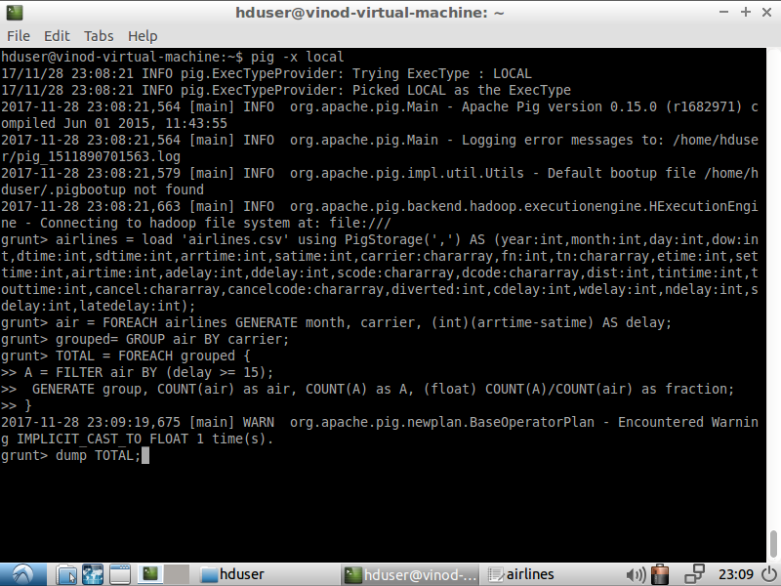

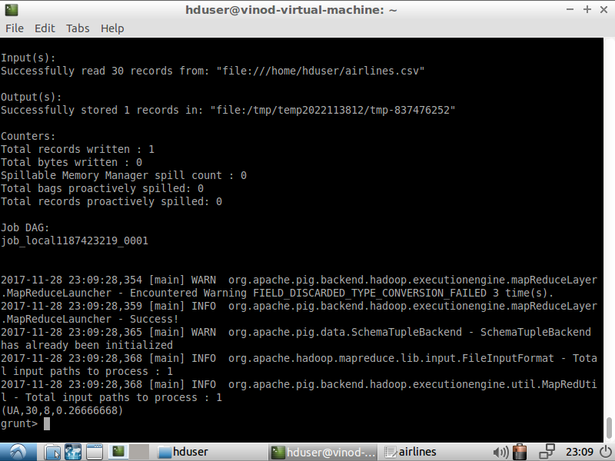

2.Fraction delay from the departure

air= FOREACH airlines GENERATE month, carrier, (int)(dtime-sdtime) as delay;

grouped= GROUP air BY carrier;

TOTAL = FOREACH grouped {

A = FILTER air BY (delay >= 15);

GENERATE group, COUNT(A) as air, COUNT(A) as A, (float) COUNT(A)/COUNT(air) as fraction;

}

dump TOTAL;

